OTHER FUNCTIONS
NOTE: These functions perform uniue action
Input data:
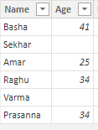
1)BLANK: By using this we can find or treat the missing values and give them new value.
Syntax: BLANK()
NOTE: In this function, there is no parameter.
The Blank value does not have datatype.
If power Bi taken null values, those values are treated as Blank values, but not taken our side for giving null values.
In this first of how to find the missing value and second one is how to give a new value in that blank value.
This function can apply in new column.
Dax Function: 1) Find the missing value
Findblank = ISBLANK(other_function[Age])
2)Given new value in that blank value.
Blank with If=IF(ISBLANK(other_function[Age]),0,other_function[Age])
NOTE: In the place of return 0, we can mention any text value also.
Output:1) 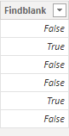 2) 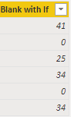

2)ERROR: By using this we can raises an error message.
Syntax: ERROR(<text>)
NOTE: It returns none.
This function can apply in new measure only.
Dax Function: Error =
Var v1=SELECTEDVALUE(other_function[Age])
Var v2=IF(ISBLANK(v1),ERROR("No Data Availble "),v1)
return v2

Output:
